Circuit Analysis using MATLAB

LAB # 12



**Spring 2022**

**CIRCUIT AND SYSTEMS 1 LAB**

Submitted by: **MUHAMMAD SADEEQ**

Registration No.: **21PWCSE2028**

Section: **C**

"On my honor, as student of University of Engineering and Technology, I have neither given nor received unauthorized assistance on this academic work.'

Submitted to:

Engr. Faiz Ullah

(July 2022)

Department of Computer Systems Engineering University of Engineering and Technology, Peshawar

**Experiment # 12**

Circuit Analysis using MATLAB

**Objectives:**

* Objectives of this lab is to analyze given circuit using MATLAB

**Apparatus:**

* Computer with PSPICE and MATLAB software installed on it

**Complex circuits:**

A complex circuit configuration is one that contains components that are neither parallel nor series with each other. If a circuit can be reduced to a single resistor, it is a series or parallel. If not, it is a complex circuit.

**Mesh Current Analysis:**

Mesh analysis is a method that is used to solve planar circuits for the currents (and indirectly the voltages) at any place in the electrical circuit. Planar circuits are circuits that can be drawn on a plane surface with no wires crossing each other.

Mesh Current Analysis Method is used to analyze and solve the electrical network having various sources or the circuit consisting of several meshes or loops with voltage or current sources. It is also known as the Loop Current Method.

In the Mesh Current method, a distinct current is assumed in the loop and the polarities of drops in each element in the loop are determined by the assumed direction of loop current for that loop.

The unknown in mesh current analysis is the current in different meshes, and the law which is applicable to solve the circuit by the mesh current method is known as Kirchhoff’s Voltage Law (KVL) which states that

In any closed circuit, the net voltage applied is equal to the sum of the product of current and resistance in other words in any closed circuit, the sum of the voltage rise is equal to the sum of voltage drop, in the direction of current flow.

**How to apply KVL in each mesh:**

* Identify the meshes.
* Assign a current variable to each mesh, using a consistent direction (clockwise or counterclockwise).
* Write Kirchhoff's Voltage Law around each mesh. ...
* Solve the resulting system of equations for all loop currents.
* Solve for any element currents and voltages you want using Ohm's Law.

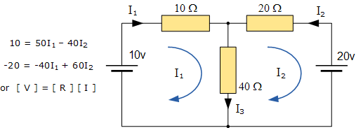

Multiplying 40 to equation (1) and 50 to equation (2)

Then adding both equations we got

-600 = 1400I2

I2 = 0.428A = 428mA

Putting the I2 value in equation (1) we got

I1 = 0.542A = 542mA

**What Is MATLAB?**

MATLAB is a high-performance language for technical computing. It integrates computation, visualization, and programming in an easy-to-use environment where problems and solutions are expressed in familiar mathematical notation. Typical uses include:

* Math and computation
* Algorithm development
* Modeling, simulation, and prototyping
* Data analysis, exploration, and visualization
* Scientific and engineering graphics
* Application development, including Graphical User Interface building

MATLAB is an interactive system whose basic data element is an array that does not require dimensioning. This allows you to solve many technical computing problems, especially those with matrix and vector formulations, in a fraction of the time it would take to write a program in a scalar with no interactive language such as C or Fortran.

The name MATLAB stands for matrix laboratory. MATLAB was originally written to provide easy access to matrix software developed by the LINPACK and EISPACK projects, which together represent the state-of-the-art in software for matrix computation.

MATLAB has evolved over a period of years with input from many users. In university environments, it is the standard instructional tool for introductory and advanced courses in mathematics, engineering, and science. In industry, MATLAB is the tool of choice for high-productivity research, development, and analysis.

MATLAB features a family of application-specific solutions called toolboxes. Very important to most users of MATLAB, toolboxes allow you to learn and apply specialized technology. Toolboxes are comprehensive collections of MATLAB functions (M-files) that extend the MATLAB environment to solve particular classes of problems. Areas in which toolboxes are available include signal processing, control systems, neural networks, fuzzy logic, wavelets, simulation, and many others.

**Using the mesh analysis to find the current flowing through the resistor R5:**

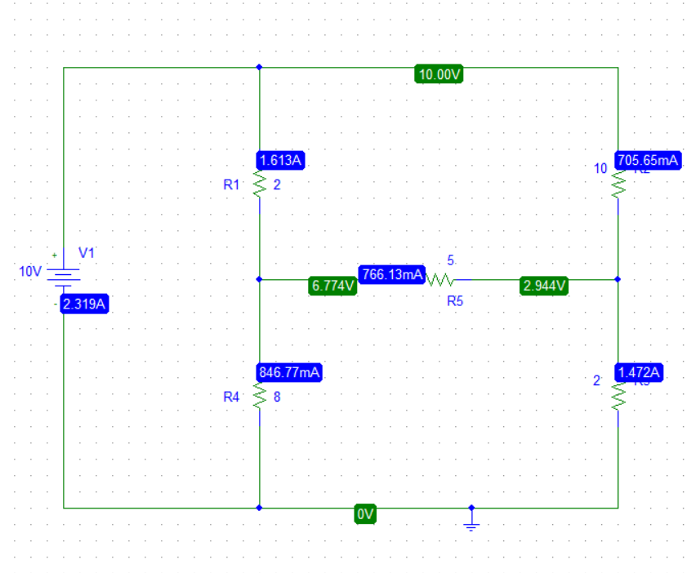

Using loop analysis and designating the loop currents as I1, I2, and I3 we obtain

The following figure

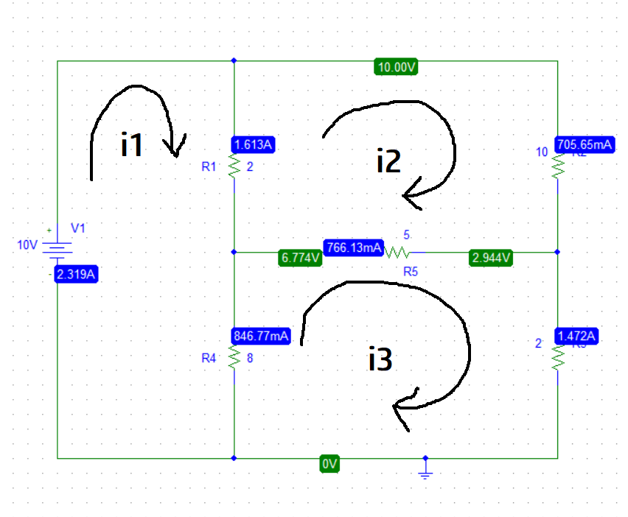

As we know that I = I3-I2

The loop equations are:

Mesh 1:

2( I 1- I2 ) + 8( I1–I3) = 10

10I1 - 2I2 - 8I3 = 10

Mesh 2:

10I2 + 5( I2 - I3 ) + 2( I2 - I1 ) = 0

-2I1 + 17I2  - 5I3 = 10

Mesh 3:

2I3 + 8( I3 - I1 ) + 5( I3 – I2 ) = 0

-8I1 - 5I2  + 15I3 = 0

In matrix form mesh 1,2,3 equation become

A*I=V

$$\left[\begin{matrix}10 & -2 & -8 \\ -2 & 17 & -5 \\ -8 & -5 & 15\end{matrix} \right] \left[\begin{matrix}I1 \\ I2 \\ I3\end{matrix}\right] = \left[\begin{matrix}10 \\ 0 \\ 0\end{matrix}\right]$$

**MATLAB CODE:**

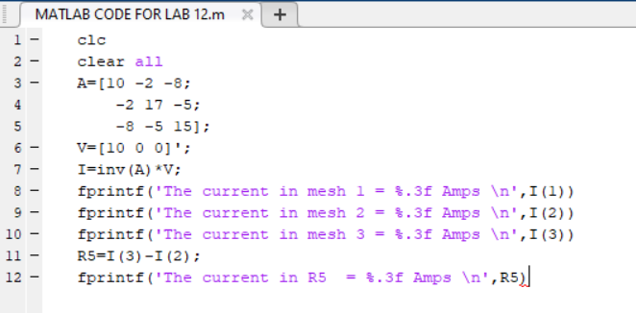

**OUTPUT:**

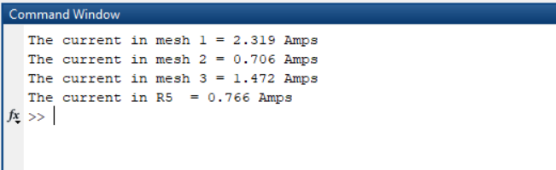

**PSPICE Verification:**



**Conclusion:**

From the experiment we concluded that the result obtained from the complex circuit by PSPICE and that by MATLAB is same.